“I need a resolution!”
Starring Lores Logan
(not final, TBD)

Story:
The game is about an average guy in a world where the resolution is missing/was stolen. There are zones so pixelated that you can’t understand anything. These zones should look like memory corrupted graphics (see link below) but that effect will be made from the programming.
This is why our hero needs to find pixel-packs. After you find enough pixel packs and pixels (pixels are dropped by enemies when they die) you’ll be able to unlock other levels. The levels should be playable many times because they will be filled with secrets. The zones where the resolution is missing should look like memory corrupted graphics (low res graphics, random ascii characters on colored blocks, randomly placed over the image to give the illusion of a graphical error). Watch this from 5:50: https://www.youtube.com/watch?v=TQfa0aRmdIc
The main villain should have something to do with computers and memory chips, or he could be some kind of alien that comes from another dimension in search for pixels and resolution. The story isn’t final right now so you have a lot of freedom.
The entire game could be made on this low-res error theme. The dialog boxes and interfaces could pixelate the background, some characters could talk in that error-code alphabet and so on. The atmosphere will be darker than BroForce but it would be nice to have colorful parts too (eg: the outside of a building could be normal but the inside could be very dark).
Character:
Our guy will only have a shotgun that he’ll have to reload every now and then (something like Dangerous Dave). We will have many powerups that, when activated, will only change the type of the bullets he has in the shotgun. We will have incendiary ammo, sniper, silencer and many others. The player will also have a secondary ammo like grenades of all sorts.
The character can’t be a brute because there will be levels where he will have to do some hacking too. He should be the usual everyday guy.
Our hero dies from the first enemy shot. He will eventually pick up a helmet or something that protects him from a single shot.
Enemies:
We will have 2 classes of enemies: the stupid melee ones (zombies, dogs, etc) and the long range smart ones (soldiers) that you’ll have avoid or kill them by hacking different systems (quest solving).
The gameplay will alternate fast paced scenes where you shoot zombies and explosive barrels with stealth mode scenes where you solve puzzles by doing some hacking.
The characters should be funny and the whole game should be funny but with some horror parody scenes. There will be scenes where you turn off the lights to find secret doors or to hide from the enemies. There could be levels where you only have a flashlight and play everything in that light cone (and maybe some red rotating lights). The engine supports dynamic shadows so there will be zones where you can hide in the shadows. We’ll have dark levels with rain and lightnings that illuminate the level for a few moments. We could also have flying drones with spotlights that you need to shoot down before they spot you.
The tiles will be 16x16 pixels in a neo-retro style. There will be 3 layers of tiles (walls, platforms and front tiles (columns, door frames, railings)) and the tileset can have semi-transparent pixels. Behind the tiles a multi layered parallax background will be drawn.
I’d like a tileset that merges to a solid dark color for the platforms and walls so you can make levels like the image below. But this isn’t really necessary if you think it would look better otherwise.
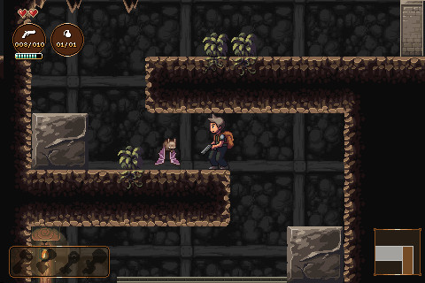
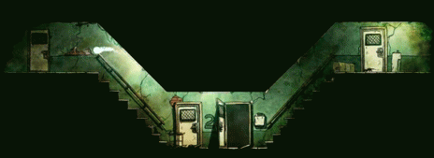
I was thinking that the characters should be 2 tiles high but I really like the characters from BroForce because they are really funny when they die and occupy a single tile and you can shoot them until they explode.
We will have a lot of blood and blood splats on the walls from the fallen enemies.
There will probably be 4 base tilesets. The story could take us from a city landscape to an abandoned lab or a jungle, to the sewers and so on.

